
Malcolm G. Boswell, Workforce Analyst * P.O. Box 2070 Gresham Oregon * (503) 666-1985 Ext. 309 * Malcolm.G.Boswell@state.or.us

A Microanalysis of Rockwood

Prepared by: Malcolm G Boswell
Workforce Analyst

This study brings together several data sets that will provide a multidimensional perspective of the Rockwood Community. The intent is to assist in better understanding opportunities and challenges for promoting strong economic development in this area. The study covers population, housing and industry data needed to get a more complete picture of Rockwood in a point in time. For comparative purposes, and because the population and housing data is based on the 2000 Census, and thus 1999 conditions, the industry data will also be based on 1999 figures available through the Employment Department’s employment and wage data (ES-202).

This microanalysis is an update of a 2000 study, however differs in that the previous study integrated data needed for more than just economic development purposes. Another important point about this and the previous study is the nature of the data sources. Current study is base don the 2000 decennial Census, where as the previous study was primarily based on the 1996 American Community Survey. Because there are some fundamental differences in methodology between both, comparisons are not recommended between them. However, both sources make similar breakouts, and thus data that was available in the previous study that is not included in this one can be obtained on an as needed basis by contacting:

Malcolm G Boswell, Workforce Analyst
Oregon Employment Department
19421 SE Stark / P.O. Box 2070
Gresham, Oregon 97030
Phone (503) 666-1985 Ext. 309
Fax (503) 492-1625
E-mail Malcolm.G.Boswell@state.or.us

Demographic data (population and housing) was obtained using American Fact-Finder online system at:

http://factfinder.census.gov/servlet/BasicFactsServlet

And the “SF3 Detailed Tables” were used to gather the base data that was later aggregated for this report. The highest quality data with the best geographic definition without actually using GIS system is by census tract where confidential data becomes less of a burden on the data availability.

Rockwood’s census tract definition has changed since the latest report where it was defined by just four census tracts, those being 96.01, 96.02, 97.02, and 98.01 (1996 American Community Survey, 1997 Geography). Geography remained the same though the same area is now covered under 6 Census tracts as tracts 96.01 and 96.02 split due to increased population density. Those to census tracts became census tracts 96.03, 96.04, 96.05, and 96.05; which along with census tracts 97.02 and 98.01 now make up the Rockwood census tract definition.

In order to maximize the analysis of the various data sets and increase its geographic relativity I have chosen to aggregate different but related data into graphical representations of the Rockwood area broken out in to the six census tracts that define it demographically.

Below is an actual census map of the Rockwood area (and each of the census tracts that make it up), to include streets and other geographic demarcations that allow the user to quickly place the Rockwood area in relation to its location in East Multnomah County.

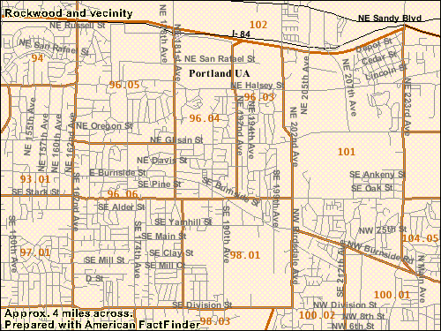
97.02

Population Distribution by Ethnicity, Sex, and Age
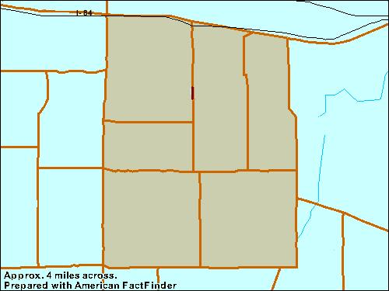
CT 96.05
Pop:……… 4,523
White:…… 74.9%
Af Am:…… 4.5%
Am Ind:….. 1.3%
Asian:…… 4.0%
Other:…… 3.4%
Hisp:……. 11.9%
CT 97.02
Pop:……… 7,013
White:…… 72.6%
Af Am:…… 1.9%
Am Ind:….. 1.2%
Asian:…… 4.2%
Other:…… 4.4%
Hisp:……. 15.7%
CT 98.01
Pop:……….. 4,482
White:…….. 52.8%
Af Am:…….. 3.5%
Am Ind:……. 0.5%
Asian:…… .. 1.5%
Other:…….. 3.5%
Hisp:……… 38.3%

Population Comparison

Multnomah:

Pop:……… 660,486
White:…… 76.5%
Af Am:…… 5.3%
Am Ind:….. 0.9%
Asian:…… 5.6%
Other:…… 4.2%
Hisp:……. 7.5%

Portland:

Pop:……… 529,025
White:…… 75.4%
Af Am:…… 6.3%
Am Ind:….. 0.9%
Asian:…… 6.3%
Other:…… 4.3%
Hisp:……. 6.8%

Gresham:

Pop:……… 90,158
White:…… 78.3%
Af Am:…… 1.7%
Am Ind:….. 0.7%
Asian:…… 2.8%
Other:…… 4.3%
Hisp:……. 12.3%

Rockwood:

Pop:……… 28,836
White:…… 68.3%
Af Am:…… 3.2%
Am Ind:….. 0.8%
Asian:…… 3.4%
Other:…… 4.3%
Hisp:……. 20.1%

CT 96.04
Pop:……… 4,757
White:…… 66.1%
Af Am:…… 3.0%
Am Ind:….. 0.5%
Asian:…… 2.8%
Other:…… 2.7%
Hisp:……. 24.9%

CT 96.06

Pop:……… 4,721
White:…… 62.2%
Af Am:…… 4.1%
Am Ind:….. 0.9%
Asian:…… 4.0%
Other:…… 7.7%
Hisp:……. 21.1%

CT 96.03
Pop:……… 3,340
White:…… 82.5%
Af Am:…… 2.5%
Am Ind:….. 0.3%
Asian:…… 3.4%
Other:…… 3.9%
Hisp:……. 7.5%

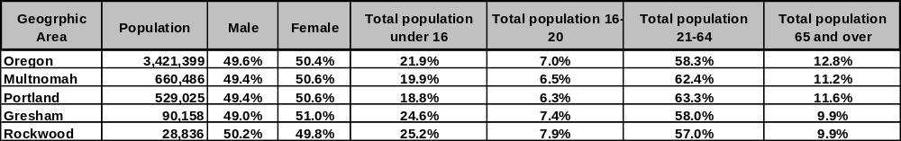

Education Attainment by Gender (people 25 years or older)
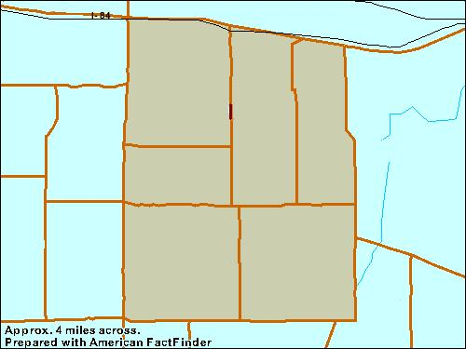

Education Attainment
Comparison

Multnomah:
< HS ............... 64,087
HS / GED ....... 102,814
Some Col ....... 115,207
Assoc ............. 27,386
BA / BS .......... 89,711
Masters > ....... 47,117

Portland:
< HS .............. 52,126
HS / GED ....... 80,947
Some Col ....... 90,825
Assoc ............. 21,255
BA / BS .......... 77,321
Masters > ...... 41,377

Gresham:
< HS ........... 9,379
HS / GED ... 15,755
Some Col .... 16,170
Assoc .......... 4,030
BA / BS ....... 7,519
Masters > .... 2,734

Rockwood:
< HS ............ 4,613
HS / GED ..... 5,338
Some Col ..... 4,343
Assoc .......... 970
BA / BS ....... 1,549
Masters > ..... 517
CT 96.05

< HS ……… 578
HS / GED … 763
Some Col … 892
Assoc ……. 128
BA / BS …… 465
Masters > … 148

CT 96.04

< HS ……… 890
HS / GED … 910
Some Col … 582
Assoc …… 161
BA / BS …… 248
Masters > … 24

CT 96.06

< HS …… 825
HS / GED … 830
Some Col … 701
Assoc …… 213
BA / BS …… 185
Masters > … 122

CT 96.03

< HS …… 388
HS / GED … 648
Some Col … 673
Assoc …… 111
BA / BS …… 274
Masters > … 82

CT 97.02

< HS …… 1,207
HS / GED … 1,411
Some Col … 1,113
Assoc …… 251
BA / BS …… 240
Masters > … 81

CT 98.01

< HS ……… 825
HS / GED … 776
Some Col … 382
Assoc …… 106
BA / BS … 137
Masters > … 60

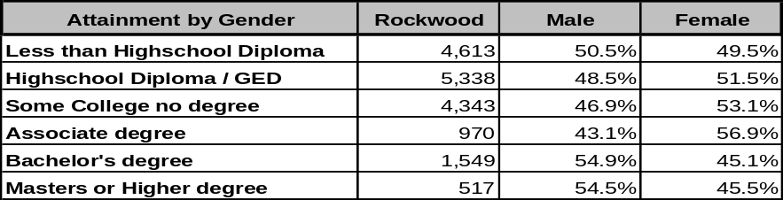

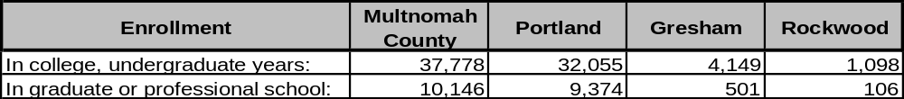

Household Income, Poverty, and Unemployment

Rockwood
Household Income

96.03:

Average.............$ 47.845
Median...............$ 51,984
Percapita...........$ 115,207

96.04:

Average.............$ 41,334
Median...............$ 47,236
Percapita...........$ 29,069

96.05:

Average.............$ 53,950
Median...............$ 58,730
Percapita...........$ 42,002

96.06:

Average.............$ 40,047
Median...............$ 39,634
Percapita...........$ 36,926

97.02:

Average.............$ 43,227
Median...............$ 47,881
Percapita...........$ 28,049

98.01:

Average.............$ 35,082
Median...............$ 35,398
Percapita...........$ 29,847

CT 96.05

Percent of population below poverty level:
13.6 %

Of those:
36.5 % are under 17
59.1 % are 18-64
4.5 % are 65 and over

CT 96.04

Percent of population below poverty level:
19.2 %

Of those:
37.2 % are under 17
57 % are 18-64
5.8 % are 65 and over

CT 96.06

Percent of population below poverty level:
27.7 %

Of those:
42.8 % are under 17
52.4 % are 18-64
4.8 % are 65 and over

CT 96.03

Percent of population below poverty level:
8.1 %

Of those:
37.3 % are under 17
52.6 % are 18-64
10.1 % are 65 and over

CT 97.02

Percent of population below poverty level:
17 %

Of those:
41.8 % are under 17
47.9 % are 18-64
10.3 % are 65 and over

CT 98.01

Percent of population below poverty level:
29.5 %

Of those:
45.8 % are under 17
52.3 % are 18-64
1.9 % are 65 and over

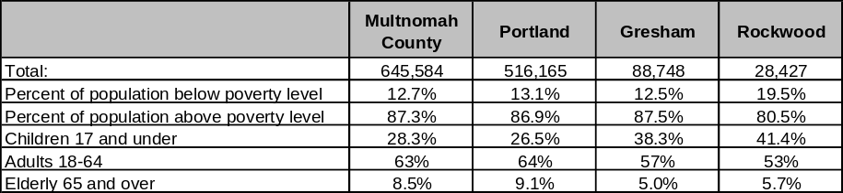

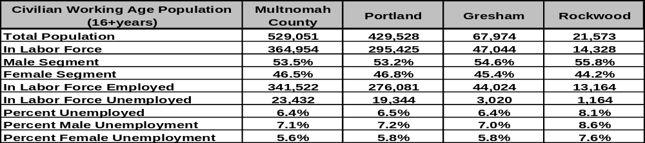

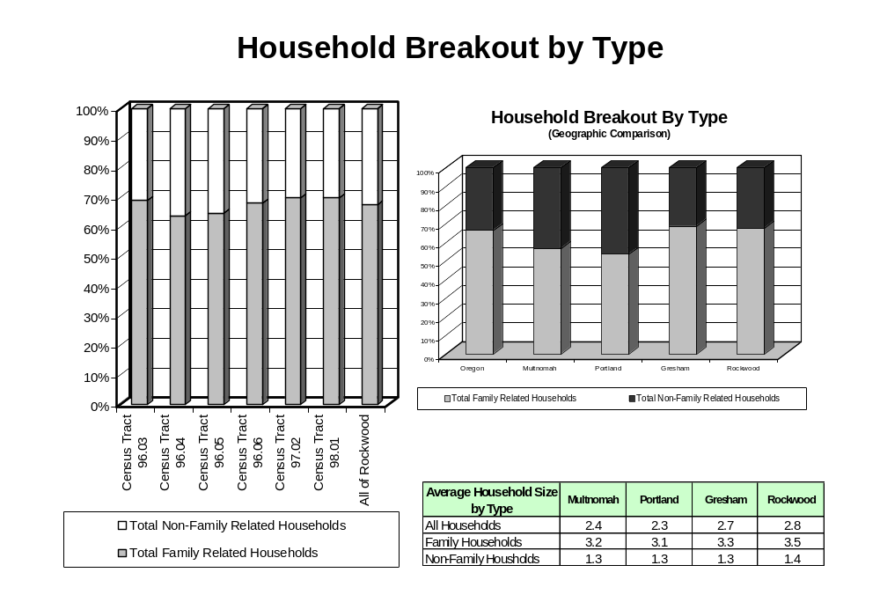
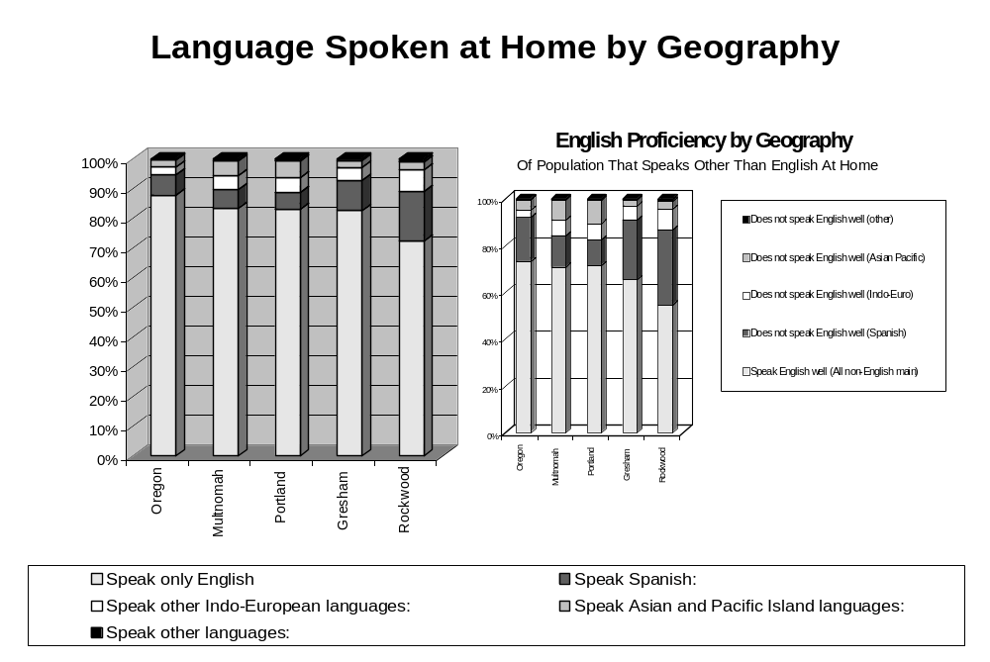
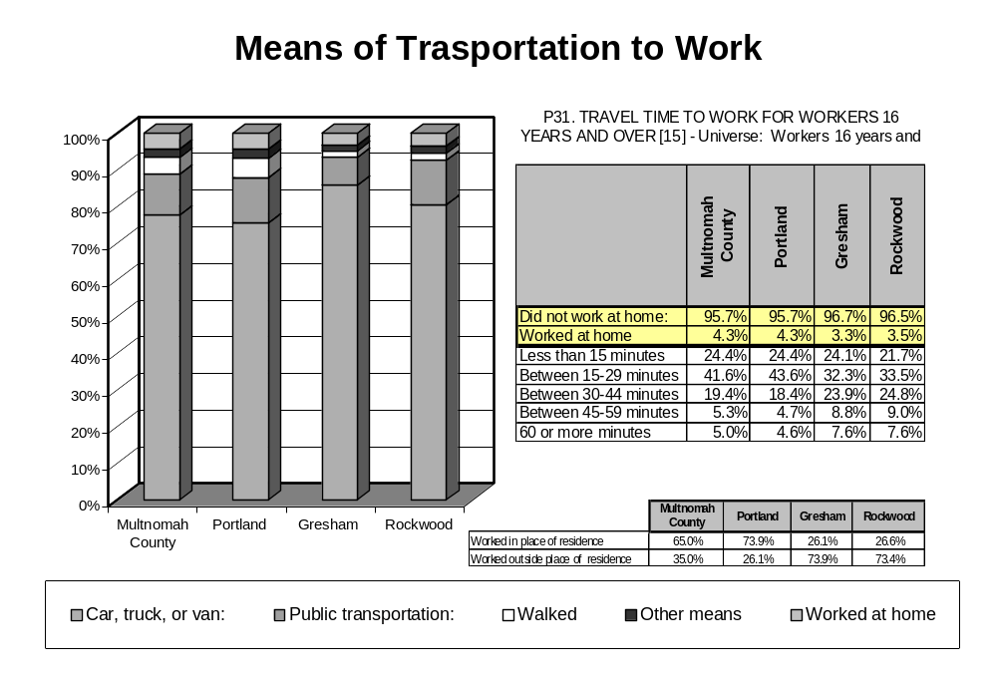

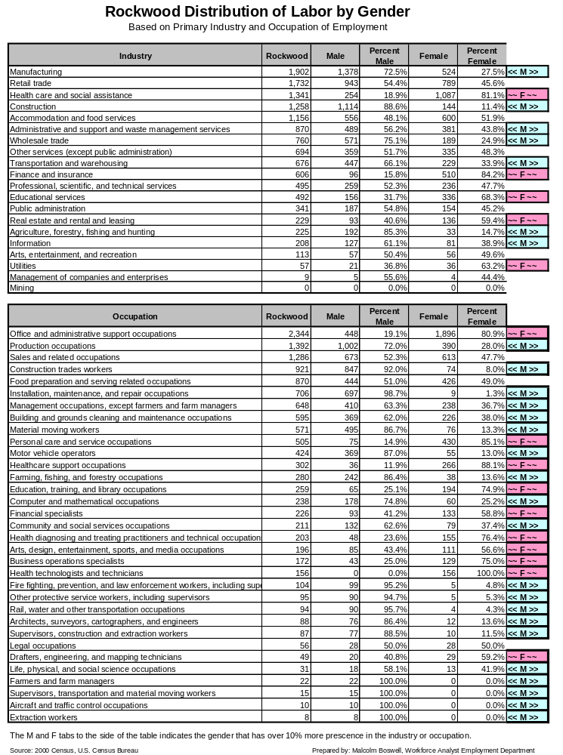

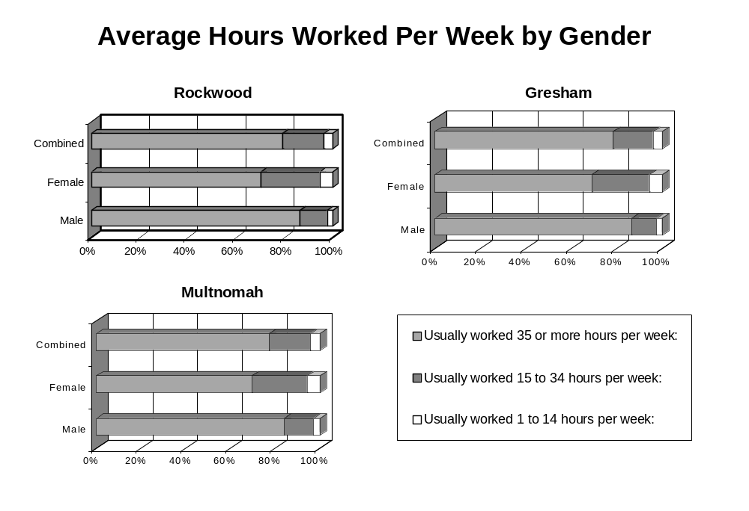

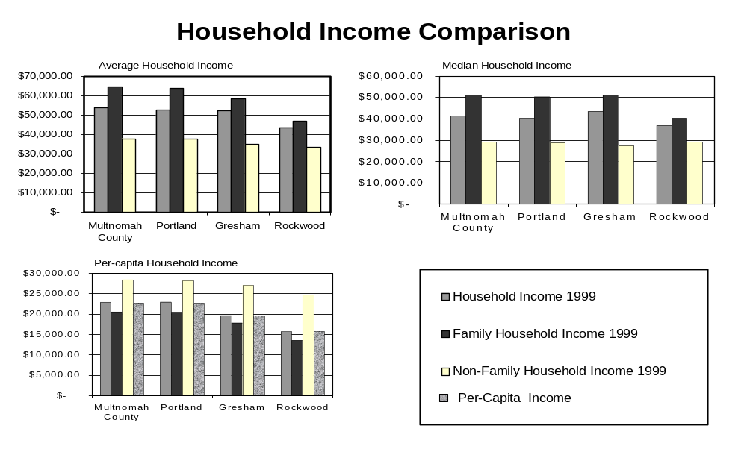
Notes: Households are represented in the census bureau three ways, family related households, non-family related households and the combination of both or simply all households regardless of relationship. Income is also provided here three ways: Average household income being the aggregate total of all household incomes (by type) divided by the total number of households by type. Mean household income being the mid-point in the list of all individual household incomes (by type). Per-capita household income is the aggregate of all household income by type divided by the total population in households (by type). The standard population per-capita income is added as a base line comparison to the household per-capita income.

Housing Data

The next two pages are designed to provide the data in a relative geographic distribution. In order to visualize the areas depicted in the graphics please refer to the following map. The relative size and shape of some of the census tracts were adjusted to allow room for data.

97.02

Rockwood Owner Occupied Housing Data by Census Tract
(Data presented according to CT geographic layout)

Census Tract 96.03

Census Tract 96.04
Census Tract 96.05
72.8 % of homes in this area valued between $100,000 to $199,999.
80.4 % of homes in this area valued between $100,000 to $199,999.
91.1 % of homes in this area valued between $100,000 to $199,999.

Breakout of owners in this housing value range by income levels:

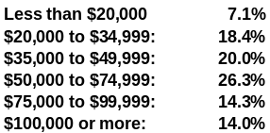

Median Income: $ 57,292
Number of owner-occupied housing: 845

Median housing value:
$ 169,400

Median Monthly Costs as a percent of income:
20.1%
Breakout of owners in this housing value range by income levels:

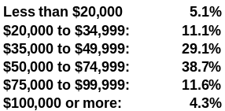

Median Income: $ 55,938
Breakout of owners in this housing value by income levels:

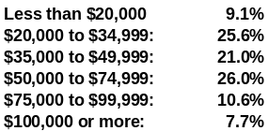

Median Income: $ 42,986

Median Age of Housing:

24 Years

Census Tract 96.06
Number of owner-occupied housing: 723

Median housing value:
$ 127,100

Median Monthly Costs as a percent of income
22.1%
Number of owner-occupied housing: 764

Median housing value:
$ 142,500

Median Monthly Costs as a percent of income
21.4%
91.2 % of homes in this area valued between $100,000 to $199,999.
Number of owner-occupied housing: 560

Median housing value:
$ 136,600

Median Monthly Costs as a percent of income:
22.3%
Breakout of owners in this housing value range by income levels:

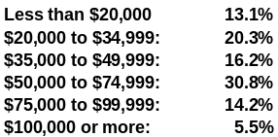

Median Income: $ 44,500

Median Age of Housing:

27 Years
Median Age of Housing:

30 Years

Median Age of Housing:

27 Years

Census Tract 97.02

Census Tract 98.01
86.4 % of homes in this area valued between $100,000 to $199,999.
78.9 % of homes in this area valued between $100,000 to $199,999.

Breakout of owners in this housing value range by income levels:

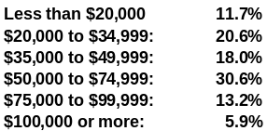

Median Income: $ 39,735
Breakout of owners in this housing value range by income levels:

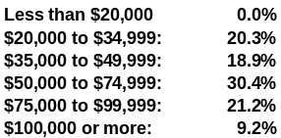

Median Income: $ 42,857
Number of owner-occupied housing: 1,736

Median housing value:
$ 129,500

Median Monthly Costs as a percent of income
22.9%
Number of owner-occupied housing: 386

Median housing value:
$ 116,700

Median Monthly Costs as a percent of income
22.2%

Median Age of Housing:

36 Years
Median Age of Housing:

24 Years

Rockwood Renter Occupied Housing Data by Census Tract
(Data presented according to CT geographic layout)

Census Tract 96.03

Census Tract 96.04
Census Tract 96.05
81.24 % of rental units in this area were rented in the
$500 to $999 range

76.53 % of rental units in this area were rented in the
$500 to $999 range

79.92 % of rental units in this area were rented in the
$500 to $999 range
Number of renter-occupied housing: 917

Median rent asked for vacant-for rent housing:
$ 575

Median Gross Rent as a percent of income:
25.6%
Breakout of renters in this housing rental range by income levels:

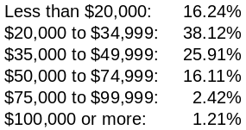

Median Income: $ 31,915
Breakout of renters in this housing rental range by income levels:

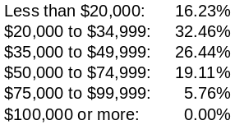

Median Income: $ 35,781
Breakout of renters in this housing rental range by income levels:

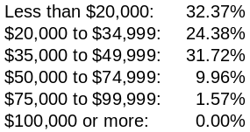

Median Income: $ 28,878

Census Tract 96.06
Census Tract 97.02

Census Tract 98.01
Breakout of renters in this housing rental range by income levels:

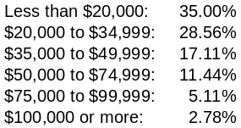

Median Income: $ 25,714
Breakout of renters in this housing rental range by income levels:

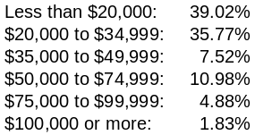

Median Income: $ 24,426
Breakout of renters in this housing rental range by income levels:

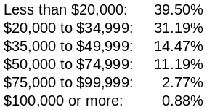

Median Income: $ 22,750
83.03 % of rental units in this area were rented in the
$500 to $999 range

67.77 % of rental units in this area were rented in the
$500 to $999 range

83.07 % of rental units in this area were rented in the
$500 to $999 range
Number of renter-occupied housing: 1084

Median rent asked for vacant-for-rent housing:
$ 554

Median Gross Rent as a percent of income:
31.5%

Number of renter-occupied housing: 726

Median rent asked for vacant-for rent housing:
$ 563

Median Gross Rent as a percent of income:
32.2%

Number of renter-occupied housing: 957

Median rent asked for vacant-for rent housing:
$ 601

Median Gross Rent as a percent of income:
29.6%

Number of renter-occupied housing: 997

Median rent asked for vacant-for rent housing:
$ 568

Median Gross Rent as a percent of income:
24.7%

Number of renter-occupied housing: 478

Median rent asked for vacant-for-rent housing:
$ 552

Median Gross Rent as a percent of income:
26%

Median Age of Housing:

27 Years
Median Age of Housing:

24 Years
Median Age of Housing:

28 Years
Median Age of Housing:

25 Years
Median Age of Housing:

31 Years
Median Age of Housing:

25 Years

